Somaiya Vidyavihar University



WEB PROGRAMMING LABORATORY
Mini Project Report-A
Project Title:
___________________LearnFlow_____________________
Submitted by:
Student Name(s): Atharva Sawant(16010124067):
Amey Salunkhe(16010124057):
Shrived Deshmukh(16010124071):

Course In-Charge:
Dr. Vaibhav Prakash Vasani
K. J. Somaiya School of Engineering
Department of Computer Engineering

Declaration
This is to certify that the mini project titled 'LearnFlow’ is a bonafide work carried out by the undersigned students under the guidance of the course instructors as part of the Web Programming Laboratory during the academic year 2025–2026.
Student Signature(s): ____________________
Date: ____________________

Acknowledgement
We express our sincere gratitude to the Department of Computer Engineering, K. J. Somaiya School of Engineering, Somaiya Vidyavihar University for providing the opportunity to work on this mini project. We would like to thank our course instructor Dr. Pradnya Gotmare for their guidance and support.

Table of Contents
Right click here in MS Word → Update Field → Update entire table.

1. Introduction
LearnFlow is a comprehensive Learning Management System (LMS) designed to facilitate seamless digital assessments. It provides a secure environment for teachers to create and manage quizzes while allowing students to enroll in classes and track their academic progress through a centralized dashboard.

2. Problem Statement
Traditional classroom assessments often struggle with manual grading errors, lack of real-time feedback, and the risk of multiple unauthorized attempts by students during online examinations. There is a need for a robust system that automates grading and strictly enforces a single-attempt policy per user to ensure academic integrity.

3. Objectives
• To develop a secure login and registration system for teachers and students.
• To implement a "One Attempt Only" logic for quizzes using backend database verification.
• To create a dynamic "Gradebook" that provides real-time scoring and performance tracking.
• To design a modern, glassmorphic UI for improved user engagement.

4. System Architecture / Web Graph
The system follows a Client-Server Architecture using the LAMP stack (Windows/Linux, Apache, MySQL, PHP):
- Frontend: HTML5, CSS3 (Modern Glassmorphism), and Lucide Icons for micro-interactions.
- Backend: PHP with PDO (PHP Data Objects) for secure, prepared SQL statements to prevent SQL injection.
- Database: MySQL relational database for managing users, classes, quizzes, and results

5. Web Pages Developed

Page Name | Description
auth.php | Handles secure user registration and login for both roles.
index.php | The main dashboard showing enrolled classes and recent performance.
take_quiz.php | Lists available quizzes with "Start" or "Completed" status indicators.
quiz_view.php | The secure quiz interface that blocks access if an attempt is already recorded.
gradebook.php | A teacher-specific view to monitor student scores and submission timestamps.
submit_quiz.php | Backend logic for calculating scores and enforcing the single-submission rule.

6. Database Design
1. Users Table
This table stores both Teachers and Students. Note the use of name to match your current code.
SQL
CREATE TABLE users (
id INT AUTO_INCREMENT PRIMARY KEY,
name VARCHAR(100) NOT NULL,
email VARCHAR(100) UNIQUE NOT NULL,
password VARCHAR(255) NOT NULL,
role ENUM('teacher', 'student') NOT NULL,
created_at TIMESTAMP DEFAULT CURRENT_TIMESTAMP
);
2. Classes Table
Classes are created by teachers. The teacher_id links back to the users table.
SQL
CREATE TABLE classes (
id INT AUTO_INCREMENT PRIMARY KEY,
class_name VARCHAR(100) NOT NULL,
class_code VARCHAR(10) UNIQUE NOT NULL,
teacher_id INT,
FOREIGN KEY (teacher_id) REFERENCES users(id) ON DELETE CASCADE
);
3. Enrollments Table
This table tracks which students have joined which classes.
SQL
CREATE TABLE enrollments (
id INT AUTO_INCREMENT PRIMARY KEY,
student_id INT,
class_id INT,
enrolled_at TIMESTAMP DEFAULT CURRENT_TIMESTAMP,
FOREIGN KEY (student_id) REFERENCES users(id) ON DELETE CASCADE,
FOREIGN KEY (class_id) REFERENCES classes(id) ON DELETE CASCADE
);
4. Quizzes Table
Each quiz is associated with a specific class.
SQL
CREATE TABLE quizzes (
id INT AUTO_INCREMENT PRIMARY KEY,
class_id INT,
quiz_title VARCHAR(255) NOT NULL,
created_at TIMESTAMP DEFAULT CURRENT_TIMESTAMP,
FOREIGN KEY (class_id) REFERENCES classes(id) ON DELETE CASCADE
);
5. Questions Table
This stores the multiple-choice questions and the correct answers for auto-grading.
SQL
CREATE TABLE questions (
id INT AUTO_INCREMENT PRIMARY KEY,
quiz_id INT,
question_text TEXT NOT NULL,
option_a VARCHAR(255) NOT NULL,
option_b VARCHAR(255) NOT NULL,
option_c VARCHAR(255) NOT NULL,
option_d VARCHAR(255) NOT NULL,
correct_option ENUM('A', 'B', 'C', 'D') NOT NULL,
FOREIGN KEY (quiz_id) REFERENCES quizzes(id) ON DELETE CASCADE
);
6. Quiz Results Table
This is the core table for your Gradebook. It records the score and total questions to prevent multiple attempts.
SQL
CREATE TABLE quiz_results (
id INT AUTO_INCREMENT PRIMARY KEY,
user_id INT NOT NULL,
quiz_id INT NOT NULL,
score INT NOT NULL,
total_questions INT NOT NULL,
submitted_at TIMESTAMP DEFAULT CURRENT_TIMESTAMP,
FOREIGN KEY (user_id) REFERENCES users(id) ON DELETE CASCADE,
FOREIGN KEY (quiz_id) REFERENCES quizzes(id) ON DELETE CASCADE
);

7. GitHub Repository
https://github.com/Atharva9627/LearnFlow/tree/main

12. Appendix (Source Code / Screenshots)
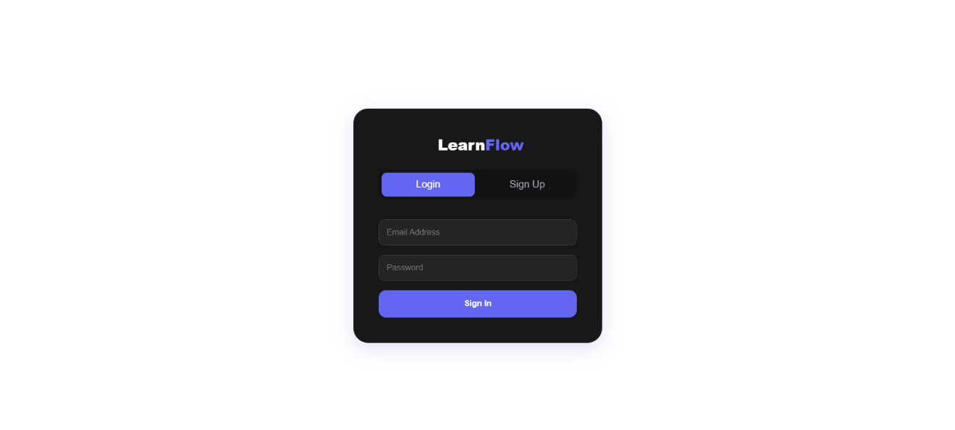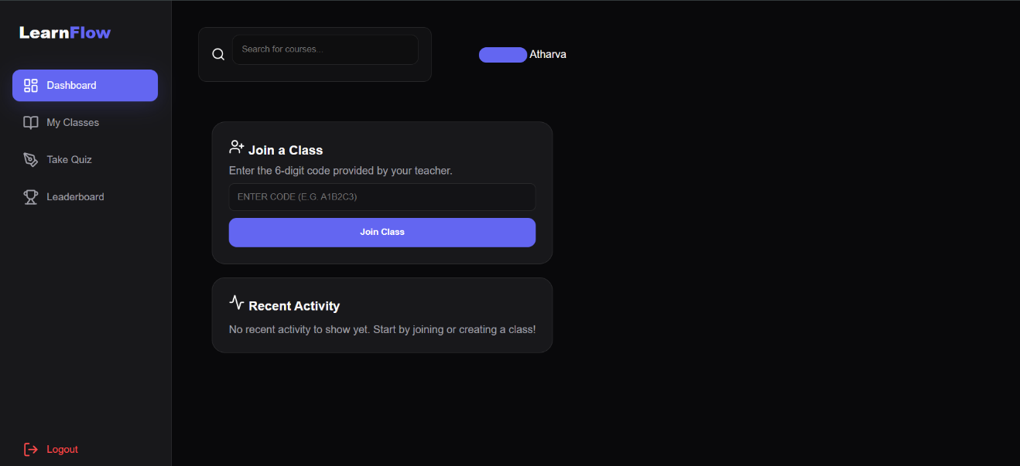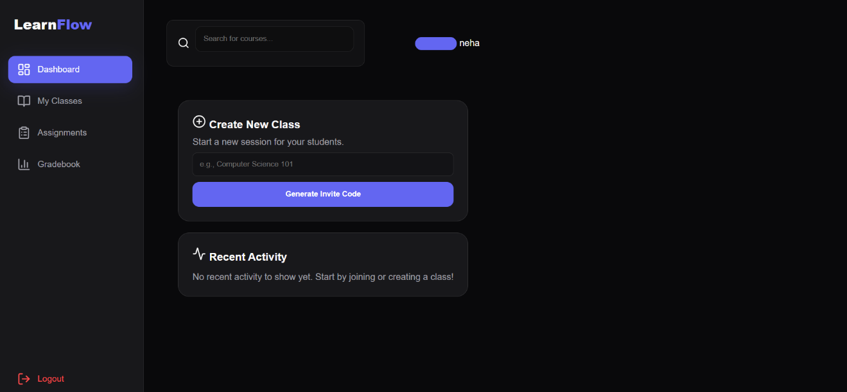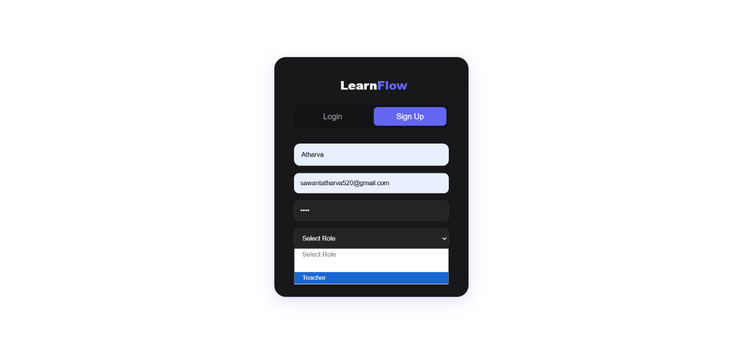

Table: List of Web Pages
Page Name | Description

Relational Model Schema
Field | Type | Description

